Activity diagrams

Send Message Specification

**Send Message**



**Send Notification to waiting list users**



**Send list of the user’s reservations**



**Request confirmation**

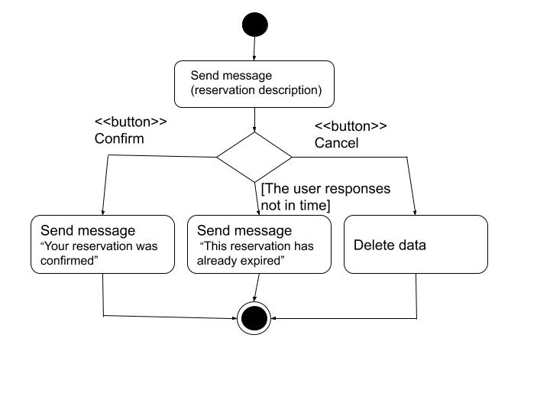

**Add the user to the waitlist**

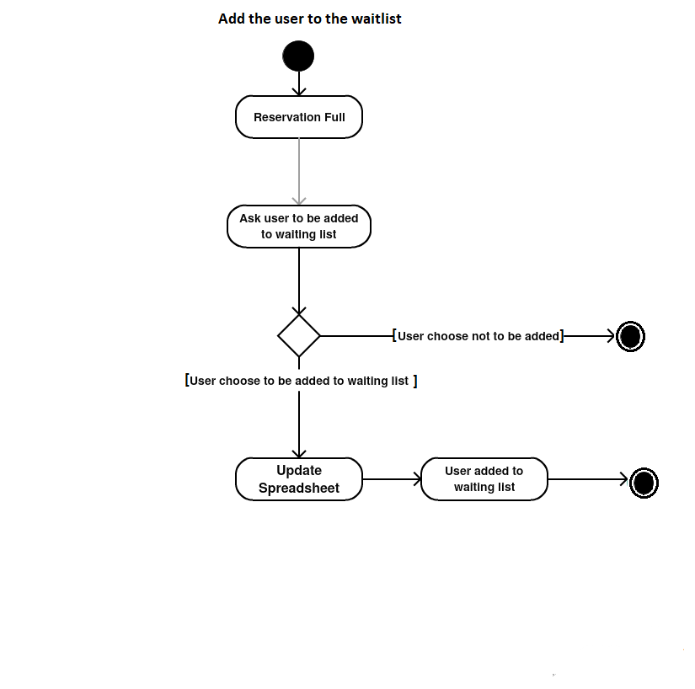

**Insert data**

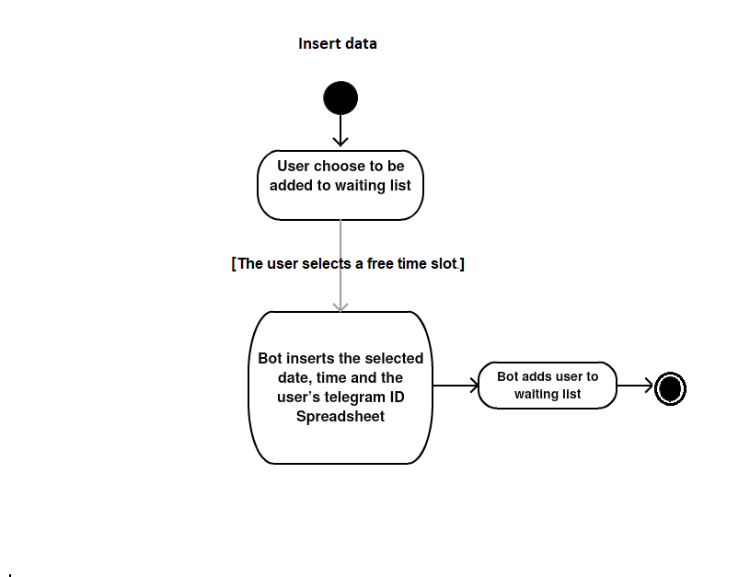

**Delete Data**

